BEFORE USING THE NOTEBOOK: State of the project folder structure

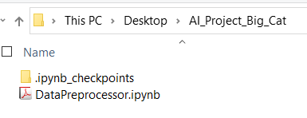

Cell1: Making changes to the notebook per season

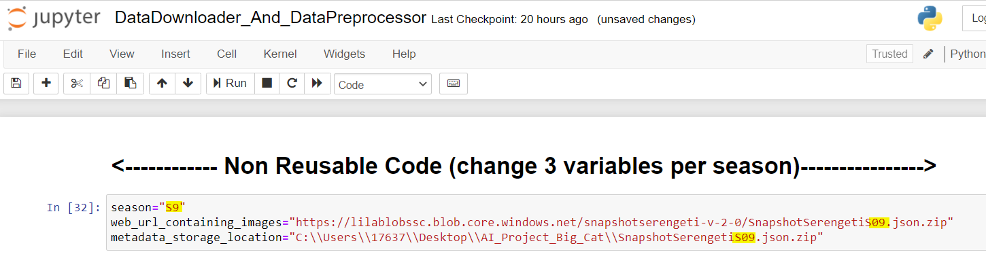

Cells2-11:Click run to linearly execute the downward flow of the cells

Cell12: Interrupt the Kernel after downloading some (1000) elephant images

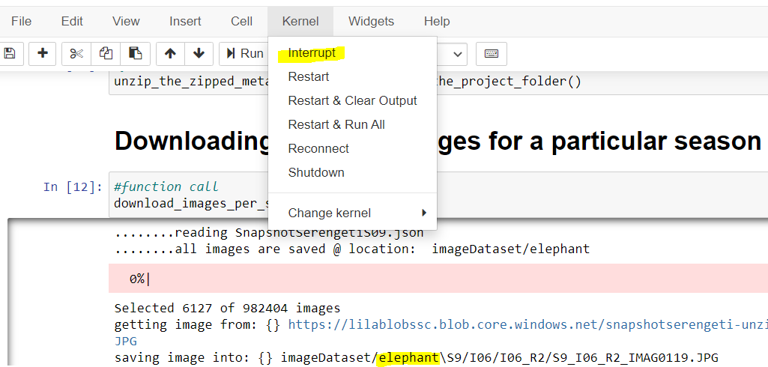

Cells13-14:Click run to linearly execute the downward flow of the cells

Cell15: Interrupt the Kernel after downloading some impala(1000) images

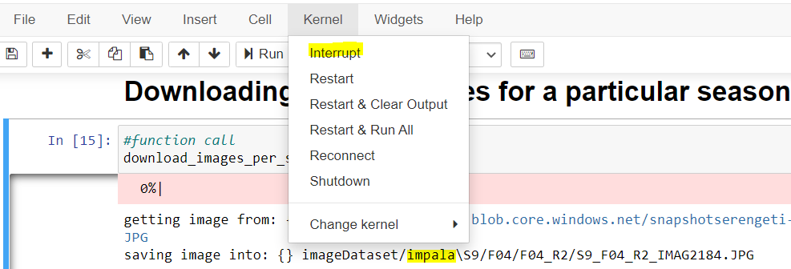

Cells16:Click run to linearly execute the downward flow of the cells

Cell17: Interrupt the Kernel after downloading some zebra(1000) images

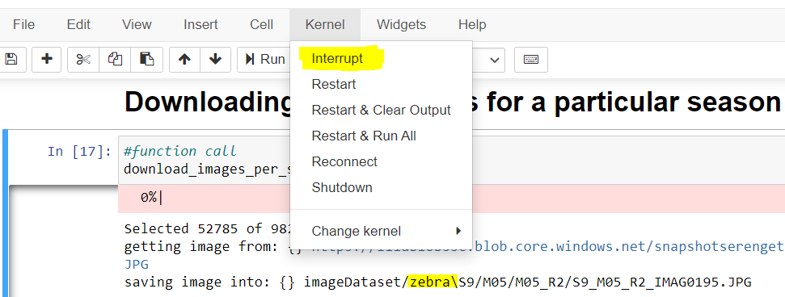

Cells18-26:Click run to linearly execute the downward flow of the cells

AFTER USING THE NOTEBOOK: State of the project folder structure

